Marist bicentenary
Message of Br Emili Turú, Superior General

MARIST BICENTENARY

Message of Br Emili Turú, Superior General
It was January 2, 1817. Marcellin Champagnat returned home with two young men. He dreamt that they – together with many more in the future – would carry the Gospel to the children and young people most in need. We consider this as the date of foundation of the Marist Institute. January 2, 2017 will mark the bicentenary of this event. What a wonderful moment to recall with grateful hearts, all the good the Holy Spirit has accomplished in the Church and in the world through the Marist Institute. In the course of these 200 years, many generations of children and young people have benefited from Marist education throughout the five continents. At the same time, it will be an opportunity to ask forgiveness for our infidelities and for the times we have failed to serve faithfully the children and young people entrusted to our care. But, above all, it must be a moment to launch ourselves into the future, into the third centenary of our Marist Institute. What a wonderful opportunity for A NEW BEGINNING!

Marists 2017

A NEW BEGINNING
Yes. We are invited to a new beginning. That is exactly what happened when Father Champagnat moved from La Valla to this valley, embarking on the bold adventure of building this house. He wanted to respond more effectively to the needs of the time. It had all begun just a few years before, and already they needed a new beginning. Here we are in Father Champagnat’s room at the Hermitage. As we look back in time, we will realize that this need to start over again has been a constant in our Marist Institute. New historical, social or even internal circumstances have forced us, on a number of occasions, to be profoundly creative; they challenged us to find responses to new emerging needs. There have, in fact, been several new beginnings before this we are facing at the onset of the 21st century.
This house today has become an eloquent symbol of the need to adapt to new times and new needs. We have tried to preserve faithfully the memory of Father Champagnat and the first brothers. However, we took the decision to demolish what no longer served those needs, adapt spaces which had become inadequate, and build a whole new section, in accordance with the demands of the present time.
On the road to 2017, Father Champagnat himself invites us to a new beginning. And this requires the commitment and cooperation of each one of us. To help us, three Marist icons will guide us on our journey. Three icons that recall essential aspects of our life and mission. Three dimensions that will most probably impact Marist life in the near future:
First, the need to direct our mission in a clearer and more decisive way towards the children and young people who are on the margins.
Second, a response from the Institute to the clear emergence of the Marist laity. And finally, a more careful attention to the mystical dimension of our lives. On the other hand, in the course of these three years we are invited to participate fully in the review process of our Constitutions. Our last General Chapter envisaged it as a way to help us revitalize our vocation. As an inspiration for us in this delicate work, we look to Brother François, whose remains rest in this church of the Hermitage.
From the age of ten, he lived next to Marcellin, whom he deeply loved, as both his writings and his life reveal. Our Founder died on June 6, 1840. It was Brother François, as first Superior General, who communicated the sad news to the Institute:
He stated: It falls to us now to recall and follow attentively his last and most influential teachings; to bring them alive in one each of us, imitating the virtues we admired in him, and, more than ever, coming closer together around our good and tender Mother.
Indeed, as Brother François said, it falls to each one of us now to offer the best of ourselves for the future of the Institute. A good way to do this will be our wholehearted participation in the review of the Constitutions, the application of the Gospel to our lives.

Montagne

October 2014 – July 2015
I am standing in Les Palais, about 6 or 7 kilometers from La Valla. Father Champagnat made his way up to this place, perhaps in rainy and foggy weather just like today, to attend the dying young man of the Montagne family. That encounter with the young Montagne was an event that profoundly marked Father Champagnat’s life, and clearly brought about the birth of the Marist Institute.
On October 28, 2014, anniversary of Father Champagnat’s meeting with the young Montagne, we will begin the ‘Montagne Year’. It will coincide with the celebration of the year of Consecrated Life in the Church worldwide. This first icon will accompany us until July 2015. It will be a reminder of the importance and urgency of our mission, as relevant today as it was in Father Champagnat’s time. Inspired by our Founder, who walked for several hours from La Valla to this place, we feel the same call to get going and meet the new Montagnes of today, wherever they may be.
The insistent call of Pope Francis to leave our own comfort zone in order to reach all the “peripheries” in need of the light of the Gospel (EG 20) echoes in our ears. In the apostolic exhortation Evangelii Gaudium (49) he states:
I prefer a Church which is bruised, hurting and dirty because it has been out on the streets, rather than a Church which is unhealthy from being confined and from clinging to its own security. If something should rightly disturb us and trouble our consciences, it is the fact that so many of our brothers and sisters are living without the strength, light and consolation born of friendship with Jesus Christ, without a community of faith to support them, without meaning and a goal in life. More than by fear of going astray, my hope is that we will be moved by the fear of remaining shut up within structures which give us a false sense of security, within rules which make us harsh judges, within habits which make us feel safe, while at our door people are starving and Jesus does not tire of saying to us: “Give them something to eat (Mk 6:37)”.
What burned in Father Champagnat’s heart as he made his way back to La Valla after encountering the young Montagne? What energy pulsed through him, leading him to found the Institute just a few months later? We might ask, are we not called to travel this same road again, allowing ourselves to be deeply challenged by the situation of the young Montagnes of today?

Fourvière

July 2015 – July 2016
On July 23, 1816, the day after their ordination, a group of young priests, full of enthusiasm, travelled to the shrine of Fourvière in Lyon. At the feet of our Lady, in the small chapel behind me, they promised to establish the Society of Mary. In 2016, we will celebrate the pledge made in that chapel 200 years ago. The icon of Fourvière, therefore, will guide us in this second year, from July 2015 to July 2016. From the beginning, the first Marists conceived the Society of Mary as a large tree with different branches: priests, brothers, sisters and lay people. The project was not recognized by the Church at that time; perhaps the historical situation was not yet ripe.
Today, circumstances are very different today. We gratefully acknowledge the fact that the Holy Spirit has made lay Marist vocations flourish among us. Thousands of lay men and women around the world feel called to live the Gospel like Mary, according to the tradition of Father Champagnat and the first brothers. The origins of the Society of Mary remind us that, as religious and laity, we come together for mission, and are called to be the Marian face of the Church through our particular way of being and building Church.
Our last General Chapter invited us to a new relationship between brothers and lay people, to better serve the inspiring mission entrusted to us by the Church. The same Chapter stated: we see our Marist future as a communion of people in the charism of Champagnat, open to the creativity of the Holy Spirit, who can lead us, perhaps, on paths we might never have imagined.

La Valla

August 2016 – August 2017
The icon that will guide our third year, from August 2016 to August 2017, is the house at La Valla. The central celebration, as you can imagine, will take place around January the 2nd, when we will celebrate 200 years of our foundation. This recently renovated house has three floors. Each of them has a symbolism we can link with the three years of preparation for the bicentenary.
We are now on the upper floor. The Apostolic Community, also gathered together in the upper room at Pentecost, immediately comes to mind. It is the space of mission: go and make disciples all over the world... The room is spacious, bright, and open to the world. It evokes the ‘Montagne Year’, and the call to move to the frontiers and to the margins of society.
On the ground floor, we have the famous table of our origins, symbol of our fraternity. Father Champagnat and the first brothers sat around this table. Today it is enriched by the presence not only of brothers, but also of Marist laity, men and women, called to build a Church with a Marian face. This is the icon for the second year, the year of ‘Fourvière’: partners in the Marist mission.
As an immediate preparation for the 22nd General Chapter, the third year will focus more on this part of the house that remained, until recently, hidden to visitors. It is a small underground space. To get there we must ‘go down’. It symbolizes that inner space in which each of us is inhabited by the Mystery. It is the space of interiority, the mystical dimension of our lives. We know that commitment to spiritual growth was a fundamental element for Father Champagnat: his deep spirit of faith opened him quite naturally to the Presence of God, whether in the forests of the Hermitage or in the noisy streets of Paris. To live like him involves cultivating silence, dedicating enough time to personal and community prayer, and listening to the Word of God, like Mary at the Annunciation. Like her, who kept and meditated everything in her heart, we strive to become contemplatives in action.
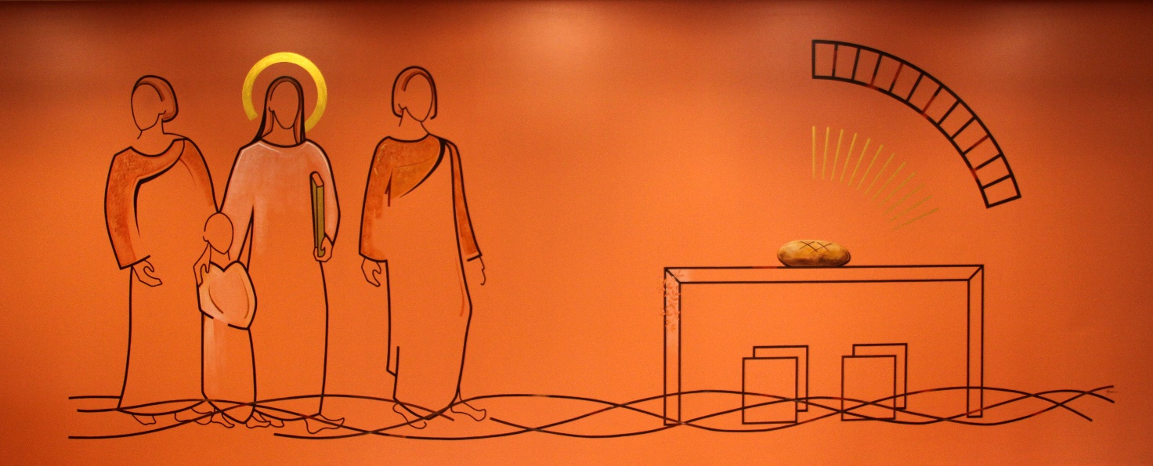

Dear Marists of Champagnat, we have these three years ahead of us to celebrate, in a spirit of faith, the bicentenary: the ‘Montagne Year’, the ‘Fourvière Year’, and the ‘La Valla Year’. I believe this mural in the community chapel of the Hermitage in some way sums up the spirit of these three years.
First, the ‘Montagne Year’: we are invited to become Jesus for the Montagnes of today, to accompany them in their journey with tenderness and gentleness. Second, the ‘Fourvière Year’: partners in mission, that is, gathered together around the figure of Jesus; on the one hand, without looking back, but at the same time, without separating ourselves from Jesus and simply going our own way. And thirdly, the ‘La Valla Year’: an invitation to cultivate the mystical dimension of our lives, that personal encounter with Jesus, the Bread of Life, so that we can also give life in fullness to the people around us.
Let us all – each according to his or her possibilities – do our part to awaken the dawn, the dawn of a renewed Marist Institute. This NEW BEGINNING will only be possible if all of us give ourselves fully to making it happen.

